|  |  |
| --- | --- |
| **Exp No: 2**  **Date: 19.2.25** | **REGISTRATION FORM** |

**AIM:**

To write a JavaScript to validate the following fields of a registration page   
a) First Name ( Name should contain alphabets and the length should not be less than 6 characters

b)Password (Password should not be less than 6 characters length)

c)Email id ( should not contain any invlaid and must follow the standard pattern [name@domain.com](mailto:name@domain.com))

d)Mobile Number(phone number should contain 10 digits only )

e)Last Name and Address ( should not be Empty)

**PROGRAM:**

<!DOCTYPE html>

<html>

<head>

<meta charset=*"ISO-8859-1"*>

<title>Insert title here</title>

</head>

<body>

<form onsubmit="return validateForm()">

<label for=*"firstName"*>First Name:</label>

<input type=*"text"* id=*"firstName"* name=*"firstName"* required><br>

<label for=*"lastName"*>Last Name:</label>

<input type=*"text"* id=*"lastName"* name=*"lastName"* required><br>

<label for=*"password"*>Password:</label>

<input type=*"password"* id=*"password"* name=*"password"* required><br>

<label for=*"email"*>Email:</label>

<input type=*"email"* id=*"email"* name=*"email"* required><br>

<label for=*"mobileNumber"*>Mobile Number:</label>

<input type=*"text"* id=*"mobileNumber"* name=*"mobileNumber"* required><br>

<label for=*"address"*>Address:</label>

<textarea id=*"address"* name=*"address"* required></textarea><br>

<input type=*"submit"* value=*"Register"*>

</form>

<script type=*"text/javascript"*>

**function** validateForm() {

// Validate First Name

**var** firstName = document.getElementById("firstName").value;

**var** namePattern = /^[A-Za-z]+$/;

**if** (firstName.length < 6 || !namePattern.test(firstName)) {

alert("First Name must contain only alphabets and be at least 6 characters long.");

**return** **false**;

}

// Validate Password

**var** password = document.getElementById("password").value;

**if** (password.length < 6) {

alert("Password must be at least 6 characters long.");

**return** **false**;

}

**OUTPUT:**

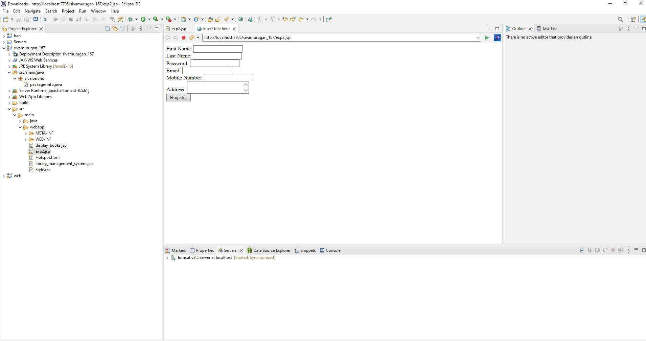

**RESULT :**Thus the experiment to create a web page that embeds a map with hotspots, frames, and links using embedded, external, and inline CSS has been successfully implemented and verified .